SonarMD + GI client web copy

Logos: Practice Logo + Sonar MD Logo

Our Partnership with SonarMD:

We use an online tool called SonarMD to stay connected to you between visits and get ahead of changes in your gut health. SonarMD is an easy and convenient way to track your Crohn’s or Ulcerative Colitis (UC) so you can stay healthy, save money and enjoy life.

How SonarMD Works:

- Eligible patients will receive an invitation to participate in the SonarMD program.
- You’ll complete a quick health assessment about your symptoms once a month via secure text or email.
- The results of your assessment are aggregated into a Sonar Score—a number related to your symptom intensity. This can be used to understand trends in your GI troubles, and what helps and hurts.
- After you complete the health assessment each month, SonarMD’s clinical team reviews your symptoms and Sonar Score. They share your information as needed with our practice so we can help proactively manage your health.

It’s easy to check in on your health. Take a peek! (use these screen shots)

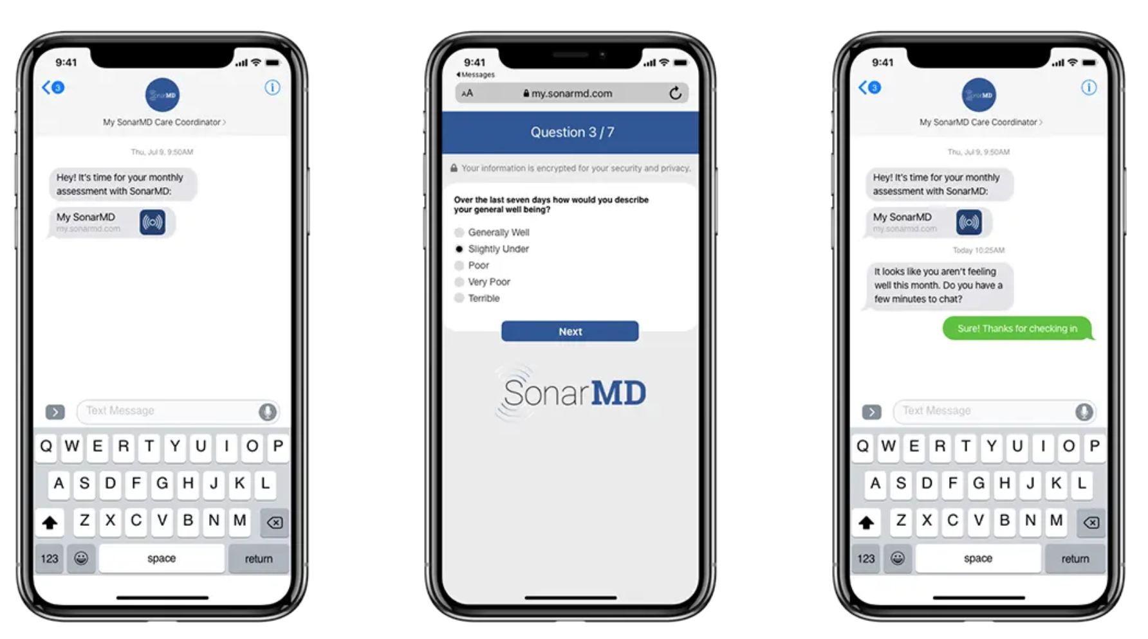

Button: Learn More About SonarMD [link to www.sonarmd.com]

FAQs: either use this link with the FAQs at the bottom: https://sonarmd.com
(Or copy/ paste some info)

How does SonarMD work?

Embed video: https://www.youtube.com/watch?v=N1jGBwHbOgY
[an alternative would be to have a clinician record a video talking about the program]

Will the data that I input be kept secure?
The site where you enter your data is password-protected and HIPAA-secure. Your information will only go to your care team so they can respond in case of a health problem.
Does my insurer see my data?
Your insurance provider never sees individual responses, scores or clinical data tracked by SonarMD. They only see aggregate – or collective — data for all SonarMD users. This helps to prove that it works to improve care and costs for everyone.
I haven’t had a flareup in forever. Why should I do this?
Many patients with Crohn’s or UC live with uncomfortable symptoms that become ‘normal’ for them. However, complications can sneak up on patients, and you might not realize how bad your symptoms have gotten until they escalate into an emergency. The short monthly health assessment has shown to catch problems that may feel insignificant to you, but could be the beginnings of a problem.

If you live with a gut health condition, it can be tough to recognize when symptoms are getting worse. SonarMD can help you stay healthy, save money, and enjoy life today.
We’re here to help you get started with SonarMD:

To enroll, contact: abcd@practice.com
555-555-5555
Note: This service is only available to [insert plan] Patients. If you have a question if you are eligible, please call our front desk 555-555-5555.

